CMPENG 331 Lab 3
Mohammad Abu Shariha
Section 002
Mma7020@psu.edu

Waveforms:
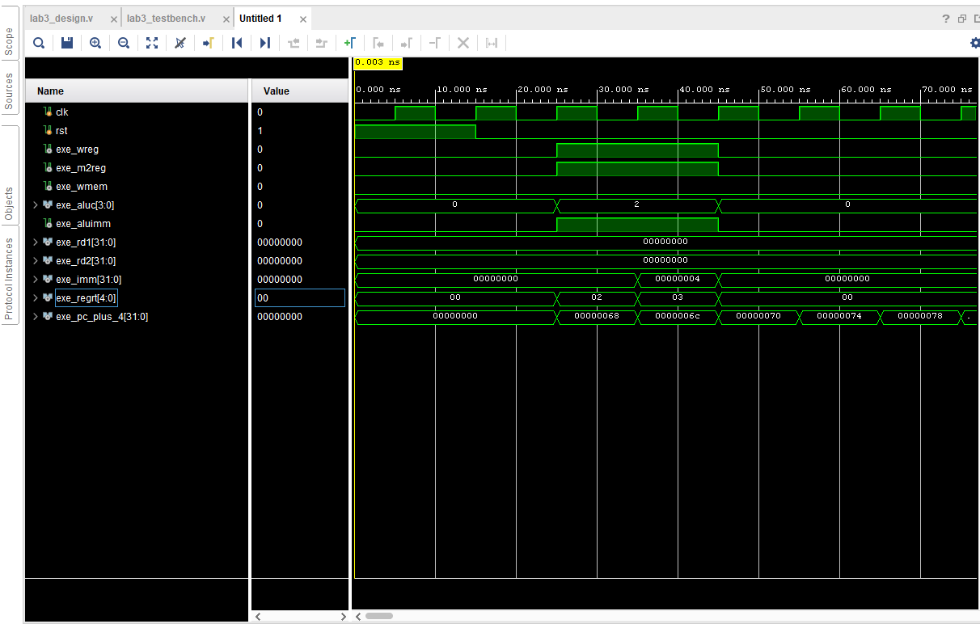
Design schematics:
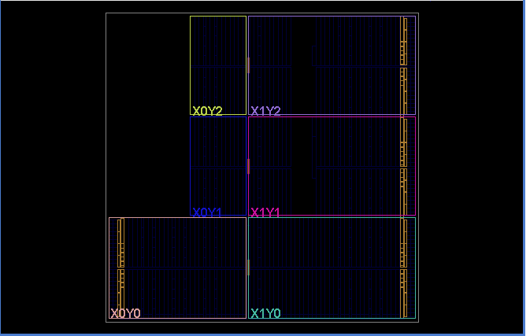
I/O Planning:
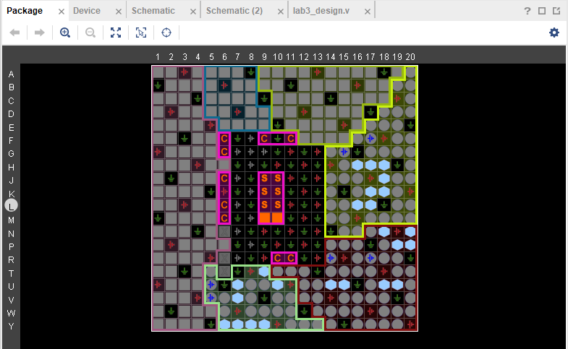
Floor Planning:
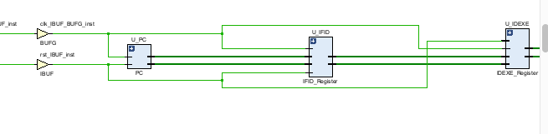
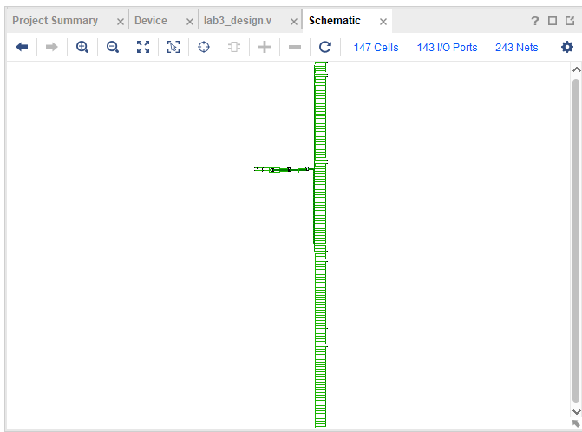
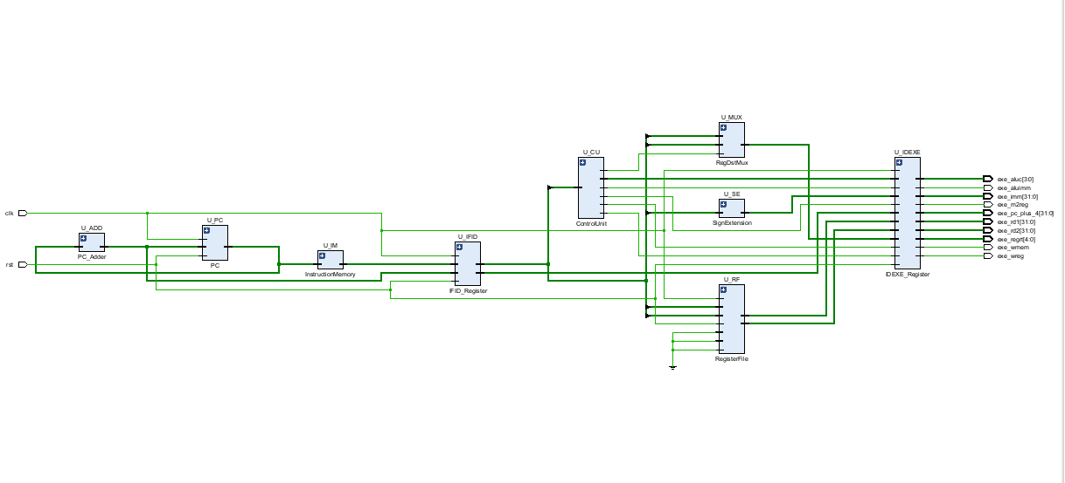
Verilog Design code:
/*
* CMPEN 331 Lab 3
*/

// toplevel Module: cpu_if_id
module cpu_if_id (
input clk,
input rst,

// Control Signals
output exe_wreg,
output exe_m2reg,
output exe_wmem,
output [3:0] exe_aluc,
output exe_aluimm,

// Data
output [31:0] exe_rd1,
output [31:0] exe_rd2,
output [31:0] exe_imm,
output [4:0] exe_regrt,
output [31:0] exe_pc_plus_4
);

//IF Stage Wire
wire [31:0] pc_current;
wire [31:0] pc_next; //PC + 4
wire [31:0] inst_if;

//IF/ID Register Wires
wire [31:0] inst_id;
wire [31:0] pc_plus_4_id;

// ID Stage Wires
wire [5:0] id_op;
wire [4:0] id_rs;
wire [4:0] id_rt;
wire [4:0] id_rd;
wire [5:0] id_func;
wire [15:0] id_imm16;

//Control Unit outputs
wire ctrl_wreg;
wire ctrl_m2reg;
wire ctrl_wmem;
wire [3:0] ctrl_aluc;
wire ctrl_aluimm;
wire ctrl_RegDst;

wire [31:0] rf_rd1;
wire [31:0] rf_rd2;

// SignExtension output
wire [31:0] imm_ext_32;

// RegDst Mux output
wire [4:0] regrt_id;

wire [4:0] wb_wa = 5'b0;
wire [31:0] wb_wd = 32'b0;
wire wb_we = 1'b0;

// Slicing instruction in ID sta
assign id_op = inst_id[31:26];
assign id_rs = inst_id[25:21];
assign id_rt = inst_id[20:16];
assign id_rd = inst_id[15:11];
assign id_func = inst_id[5:0];
assign id_imm16 = inst_id[15:0];

// IF Stage-

// 1. (PC)
PC U_PC (
.clk(clk),
.rst(rst),
.next_pc(pc_next),
.current_pc(pc_current)
);

// 2.(PC + 4)
PC_Adder U_ADD (
.pc_in(pc_current),
.pc_out(pc_next)
);

// 3. IM
InstructionMemory U_IM (
.addr(pc_current),
.inst(inst_if)
);

// 4. IF/ID
IFID_Register U_IFID (
.clk(clk),
.rst(rst),
.if_inst_in(inst_if),
.if_pc_plus_4_in(pc_next),
.id_inst_out(inst_id),
.id_pc_plus_4_out(pc_plus_4_id)
);

// ID Stage

// 5. Control Unit
ControlUnit U_CU (
.op(id_op),
.wreg(ctrl_wreg),
.m2reg(ctrl_m2reg),
.wmem(ctrl_wmem),
.aluc(ctrl_aluc),
.aluimm(ctrl_aluimm),
.RegDst(ctrl_RegDst)
);

// 6. Reg File
RegisterFile U_RF (
.clk(clk),
.rst(rst),
.rr1(id_rs),
.rr2(id_rt),
.wa(wb_wa),
.we(wb_we),
.wd(wb_wd),
.rd1(rf_rd1),
.rd2(rf_rd2)
);

// 7.Sign Exten
SignExtension U_SE (
.imm_in(id_imm16),
.imm_out(imm_ext_32)
);

// 8. for 'regrt' signal)
RegDstMux U_MUX (
.in_rt(id_rt),
.in_rd(id_rd),
.sel(ctrl_RegDst),
.out_regrt(regrt_id)
);

// 9. ID/EXE Pipeline Register
IDEXE_Register U_IDEXE (
.clk(clk),
.rst(rst),
//Inputs from ID Stage
.in_wreg(ctrl_wreg),
.in_m2reg(ctrl_m2reg),
.in_wmem(ctrl_wmem),
.in_aluc(ctrl_aluc),
.in_aluimm(ctrl_aluimm),
.in_rd1(rf_rd1),
.in_rd2(rf_rd2),
.in_imm(imm_ext_32),
.in_regrt(regrt_id),
.in_pc_plus_4(pc_plus_4_id),
// EXE Stage
.out_wreg(exe_wreg),
.out_m2reg(exe_m2reg),
.out_wmem(exe_wmem),
.out_aluc(exe_aluc),
.out_aluimm(exe_aluimm),
.out_rd1(exe_rd1),
.out_rd2(exe_rd2),
.out_imm(exe_imm),
.out_regrt(exe_regrt),
.out_pc_plus_4(exe_pc_plus_4)
);

endmodule

// 1 Program Counter
module PC (
input clk,
input rst,
input [31:0] next_pc,
output reg [31:0] current_pc
);

always @(posedge clk, posedge rst) begin
if (rst)
current_pc <= 32'd100;
else
current_pc <= next_pc;
end
endmodule

// 2. PC Adder
module PC_Adder (
input [31:0] pc_in,
output [31:0] pc_out
);
assign pc_out = pc_in + 32'd4;
endmodule

// 3. Instruction Memory
module InstructionMemory (
input [31:0] addr,
output [31:0] inst
);
reg [31:0] rom[0:63];
integer i;

initial begin
//Initialize all to NOP (sll $0, $0, 0)
for (i = 0; i < 64; i = i + 1) begin
rom[i] = 32'h00000000;
end

// Load the lab instructions
rom[25] = 32'h8C220000; // Address 100
rom[26] = 32'h8C230004; // Address 104
end

// Asynchronous read ( get from Vverilog3slide 10/13)
assign inst = rom[addr[7:2]];
endmodule

// 4.IF/ID Pipeline Register
module IFID_Register (
input clk,
input rst,
input [31:0] if_inst_in,
input [31:0] if_pc_plus_4_in,
output reg [31:0] id_inst_out,
output reg [31:0] id_pc_plus_4_out
);

always @(posedge clk, posedge rst) begin
if (rst) begin
id_inst_out <= 32'h00000000;
id_pc_plus_4_out <= 32'h00000000;
end else begin
id_inst_out <= if_inst_in;
id_pc_plus_4_out <= if_pc_plus_4_in;
end
end
endmodule

// 5. Control Unit
module ControlUnit (
input [5:0] op,
output reg wreg,
output reg m2reg,
output reg wmem,
output reg [3:0] aluc,
output reg aluimm,
output reg RegDst
);

// Verilog2 75
parameter OP_LW = 6'b100011;
parameter ALU_ADD = 4'b0010;

// Verilog_1 95 and Verilo2 p25
always @(*) begin
if (op == OP_LW) begin
wreg = 1'b1;
m2reg = 1'b1;
wmem = 1'b0; // Not writing to memory
aluc = ALU_ADD;
aluimm = 1'b1;
RegDst = 1'b0;
end
else begin
wreg = 1'b0;
m2reg = 1'b0;
wmem = 1'b0;
aluc = 4'b0000;
aluimm = 1'b0;
RegDst = 1'b0;
end
end
endmodule

// 6. Register File
module RegisterFile (
input clk,
input rst,
input [4:0] rr1,
input [4:0] rr2,
input [4:0] wa, // Write register address
input we, // Write enable
input [31:0] wd,
output [31:0] rd1, //Read data 1
output [31:0] rd2 //ead data 2
);
reg [31:0] registers[0:31];

// Verilog3, slide 13)
integer i;
always @(posedge clk, posedge rst) begin
if (rst) begin
for (i = 0; i < 32; i = i + 1) begin
registers[i] <= 32'h00000000;
end
end
else if (we && (wa != 5'b0)) begin
registers[wa] <= wd;
end
end

assign rd1 = (rr1 == 5'b0) ? 32'b0 : registers[rr1];
assign rd2 = (rr2 == 5'b0) ? 32'b0 : registers[rr2];

endmodule

// 7. Sign Extension

module SignExtension (
input [15:0] imm_in, // 16 immediate
output [31:0] imm_out // 32t sign-extended immediate
);
// erilog1, slide 60)
assign imm_out = {{16{imm_in[15]}}, imm_in};
endmodule

// 8. RegDst Mux (for 'regrt')
module RegDstMux (
input [4:0] in_rt,
input [4:0] in_rd, // From inst[15:11]
input sel,
output [4:0] out_regrt
);

// Verilog2f, slide 8)
assign out_regrt = (sel == 1'b0) ? in_rt : in_rd;
endmodule

// 9. ID/EXE Pipeline Register
module IDEXE_Register (
input clk,
input rst,
input in_wreg,
input in_m2reg,
input in_wmem,
input [3:0] in_aluc,
input in_aluimm,
input [31:0] in_rd1,
input [31:0] in_rd2,
input [31:0] in_imm,
input [4:0] in_regrt,
input [31:0] in_pc_plus_4,
// Outputs to EXE Stage
output reg out_wreg,
output reg out_m2reg,
output reg out_wmem,
output reg [3:0] out_aluc,
output reg out_aluimm,
output reg [31:0] out_rd1,
output reg [31:0] out_rd2,
output reg [31:0] out_imm,
output reg [4:0] out_regrt,
output reg [31:0] out_pc_plus_4
);

// On reset, clear all values (flushes the pipeline)
always @(posedge clk, posedge rst) begin
if (rst) begin
out_wreg <= 1'b0;
out_m2reg <= 1'b0;
out_wmem <= 1'b0;
out_aluc <= 4'b0;
out_aluimm <= 1'b0;
out_rd1 <= 32'b0;
out_rd2 <= 32'b0;
out_imm <= 32'b0;
out_regrt <= 5'b0;
out_pc_plus_4 <= 32'b0;
end else begin
out_wreg <= in_wreg;
out_m2reg <= in_m2reg;
out_wmem <= in_wmem;
out_aluc <= in_aluc;
out_aluimm <= in_aluimm;
out_rd1 <= in_rd1;
out_rd2 <= in_rd2;
out_imm <= in_imm;
out_regrt <= in_regrt;
out_pc_plus_4 <= in_pc_plus_4;
end
end
endmodule
Test bench code:
/*
* CMPEN 331 Lab 3 test bench
*/

`timescale 1ns/1ps

module testbench;

reg clk;
reg rst;

wire exe_wreg;
wire exe_m2reg;
wire exe_wmem;
wire [3:0] exe_aluc;
wire exe_aluimm;
wire [31:0] exe_rd1;
wire [31:0] exe_rd2;
wire [31:0] exe_imm;
wire [4:0] exe_regrt;
wire [31:0] exe_pc_plus_4;

cpu_if_id UUT (
.clk(clk),
.rst(rst),
.exe_wreg(exe_wreg),
.exe_m2reg(exe_m2reg),
.exe_wmem(exe_wmem),
.exe_aluc(exe_aluc),
.exe_aluimm(exe_aluimm),
.exe_rd1(exe_rd1),
.exe_rd2(exe_rd2),
.exe_imm(exe_imm),
.exe_regrt(exe_regrt),
.exe_pc_plus_4(exe_pc_plus_4)
);

//Generate Clock
initial begin
clk = 0;
end
always #5 clk = ~clk;

// (Reset)
initial begin
rst = 1'b1;

#15;

rst = 1'b0;

#50;

$finish;
end

initial begin
$monitor("Time=%0t ns\n\
\" --- IF Stage ---\n\
\" PC_current: %d (0x%h)\n\
\" --- IF/ID Register (Internal) ---\n\
\" IF/ID_inst_out: 0x%h\n\
\" IF/ID_pc_plus_4: %d (0x%h)\n\
\" --- ID/EXE Register (Outputs) ---\n\
\" ID/EXE_wreg: %b\n\
\" ID/EXE_m2reg: %b\n\
\" ID/EXE_wmem: %b\n\
\" ID/EXE_aluimm: %b\n\
\" ID/EXE_aluc: 0x%h\n\
\" ID/EXE_rd1: 0x%h\n\
\" ID/EXE_rd2: 0x%h\n\
\" ID/EXE_imm: 0x%h\n\
\" ID/EXE_regrt: %d\n\
\" ID/EXE_pc_plus_4: %d (0x%h)\n\
\"=======================================\n",
$time,
UUT.U_PC.current_pc, UUT.U_PC.current_pc,
UUT.U_IFID.id_inst_out,
UUT.U_IFID.id_pc_plus_4_out, UUT.U_IFID.id_pc_plus_4_out,

exe_wreg,
exe_m2reg,
exe_wmem,
exe_aluimm,
exe_aluc,
exe_rd1,
exe_rd2,
exe_imm,
exe_regrt,
exe_pc_plus_4, exe_pc_plus_4
);
end

endmodule

